Day9 SOCKETPROGRAMMING

FILE HANDLING BETWEEN CLIENT AND SERVER

SERVER SIDE

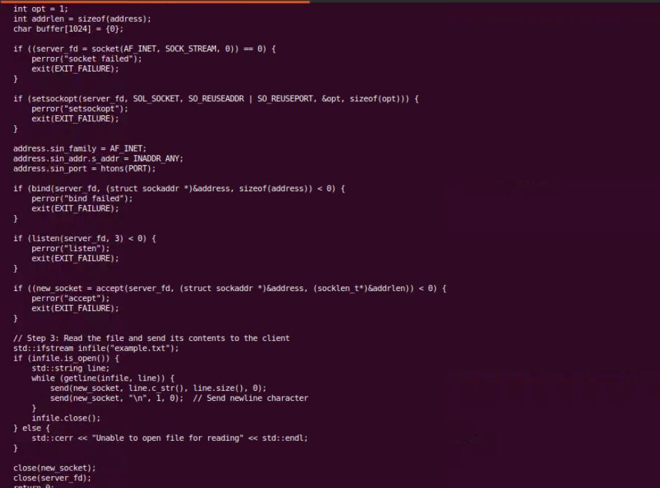

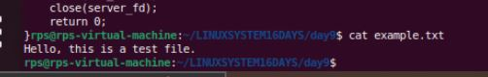

CLIENT SIDE

